Sequence Diagrams:

C:\OSCAR IVAN\McGill\Winter 2016\ECSE 321 Intro to Soft Eng\Project\HomeAudioSystem\Group02\Diagrams\AddAlbum-Requirements Level Diagram.png

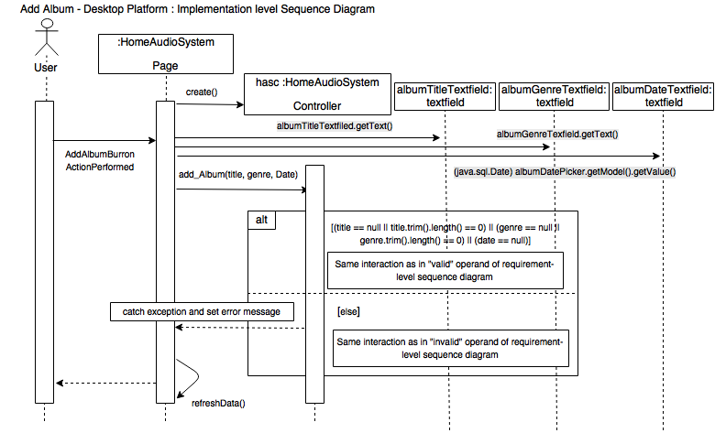

C:\OSCAR IVAN\McGill\Winter 2016\ECSE 321 Intro to Soft Eng\Project\HomeAudioSystem\Group02\Diagrams\AddAlbum-Implementation Level -Android.png

C:\Users\oscarivan\Downloads\AddAlbum-Web (1).png